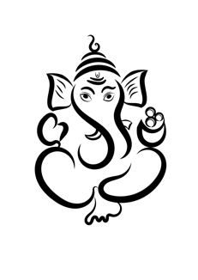

**!!OM NAMO GANESHAYA NAMAH!!**

**BIO-DATA**

Photo

Name :

Date of birth :

Time :

Cast :

Gotra :

Height :

Complexion :

Education :

Occupation :

**Family Details**

Father :

Mother :

Siblings :

**Address for Communication**

Phone :

Email :

Contact :

